Dream Big, Scale Down - Part 1

Updated automatically every 5 minutes

**Dream Big, Scale Down - Part 1**

**Introduction**

In this exercise, you and your team of fellow marine microbial ecologists at UCSB need to develop a hypothesis and design an experiment that tests that hypothesis. You will at first not be hindered by any logistics, so you can *‘dream big’* to design an experiment without any constraints (you have all the time, money, resources and help you would want). You will then be presented with real logistical constraints that any marine microbial ecologist would be faced with. You’ll have to *‘scale down’* your experimental design so that it addresses those constraints but still can effectively test your hypothesis.

In this part of the exercise, you will focus on developing your hypothesis(es).

**Generating a Hypothesis**

A research study typically stems from an **observation**. For example, a marine microbial ecologist such as yourself might notice harmful algal blooms becoming more frequent in their field site and might set out to investigate why. They’ll go through the **scientific method**, a logical problem-solving approach, to follow up on their observation.

Living in California, you got curious about wildfires so you explored some CAL FIRE data on major fires (> 500 acres) from 2013 - 2018. You then stumbled upon the satellite image below, which depicts the Thomas Fire on December 5, 2017.

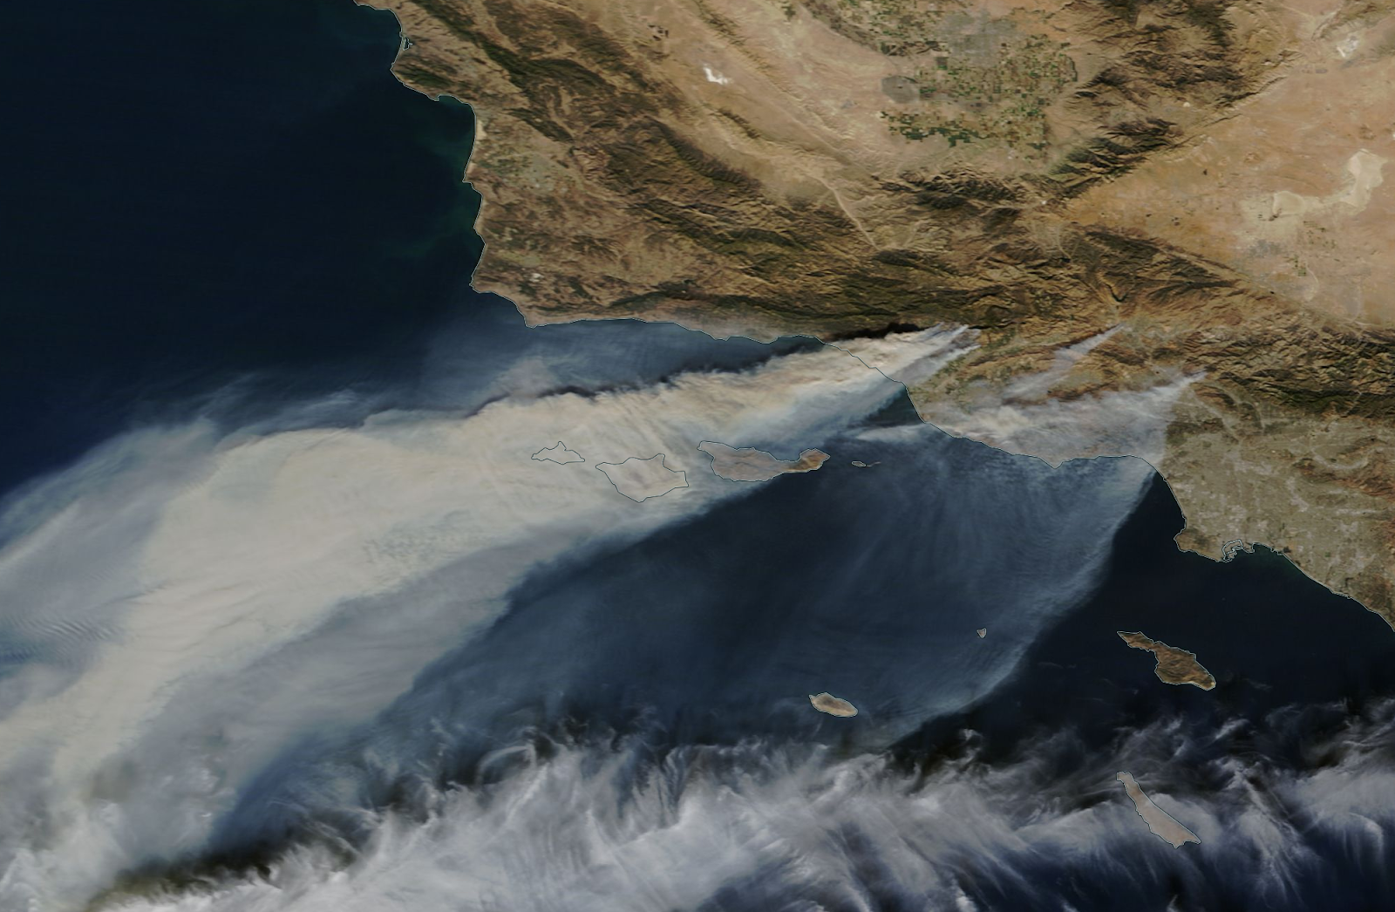

*NASA image courtesy NASA Worldview application operated by the NASA/Goddard Space Flight Center Earth Science Data and Information System (ESDIS) project*

You also found before and after images of the Montecito debris flow that immediately followed the rain that helped end the Thomas Fire.

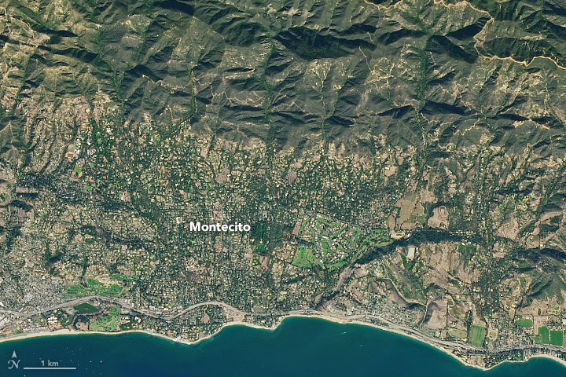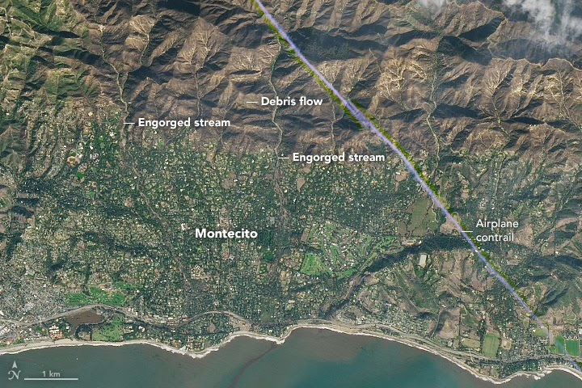

*NASA Earth Observatory images by Joshua Stevens, using Landsat data from the U.S. Geological Survey*

*Left: November 23, 2017, Right: January 10, 2018*

**Observations**

What observations can you make based on the images above and any knowledge you have/gained about wildfires in California?

**Questions**

As scientists who study marine bacterioplankton and their interactions with dissolved organic matter (DOM) in the Santa Barbara Channel, what questions might you pose from these observations?

**Hypotheses**

Now, form some hypotheses based on these observations and questions. Later, you and your team will design controlled experiments for collecting and analyzing data. Using that data, you’ll then be able to draw conclusions and form new questions for new research!

Remember:

* **A hypothesis doesn’t have to be right**. It’s a possible explanation that is *testable*. You can test it to see if it is likely correct or if you need to make a new hypothesis.
* **Hypotheses are explanations but not all explanations are hypotheses**. A valid hypothesis must be *testable* and *falsifiable*. For example, “Between SAR11 and Vibrio, SAR11 is the better bacterium" is not a good hypothesis, because no experiment can test this statement and show it to be false. A better hypothesis in this case could be, for example, “Between SAR11 and Vibrio, SAR11 is the bacterium better suited to nutrient-poor conditions”.

**Predictions**

Predict some outcomes you might expect if your hypotheses were to be correct.

Published by [Google Drive](https://docs.google.com/)–[Report Abuse](https://docs.google.com/u/0/abuse?id=AKkXjoycZ5FoIz1Vg3n4rTsEB0lywMq6bXSguFmgaBcHYbZ6rTjrGDn3hzEM1ooXT8ATPML1Spb-rzYbtjofDyU:0)